Theory of compilation and translation

Course technical details

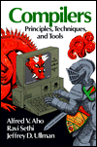
- Several assignments
- Final project

Course book:
A.Aho, R.Sethi, J.Ullman
Addison-Wesley 1986
Compilers - principles, techniques and tools.

Assignments:
Wet and dry – both theoretical and practical

Programming language:
C - (strict C)

Brief course overview

- Translation and interpretation - techniques, algorithms, data structures for translating programming languages
- Basic compiler parts – theory and practice behind them
- Building a simple compiler (theory into practice)

Try it yourself

Course in which theory and practice really come together.

Main idea of the course:

think design implement

Why study compilers?

1. To write compilers and interpreters for various programming languages.
2. To understand what is possible (or not) and difficult (or not) in programming language design.
4. To understand and write better programs.
3. To learn system tools for writing compilers – flex and bison.
4. Compilation is a great combination of both theory and practice.
5. It binds together many different areas of computer science:
- Formal language theory
- Programming language design
- Software design
- Architecture

?

What compiler does?

What features did you like in compiler?

What are compilers?

Basic definition
Compiler is a program that translates a program written in one language (called source language) into a program written in another language (called target language).

Source program
Target program
compiler

Translated program - target program - is functionally equivalent to source program.

Sometimes compiler translates one format into another format.

During the compilation compiler also checks grammar, performs error checking and optimization.

Source language is usually a high-level language:
- like C,
- Pascal,
- C++,
- or Java.

Target language is usually a low-level language:
- like Assembly
- or machine language
- or byte-code.

Sometimes you can translate from one high language into another high language.
Pascal → Compiler → C

More examples of translations
Translator | Target language | Sourse language
compiler | machine code, machine-specific assembler, JVM | C, C++, Pascal, Ada, Java
assembler | machine code | Assembly
linker/loader | “executable” code | “object” code
file compressor | compressed file | regular file

Compiler language

Modern compilers are implemented in a high level language.

Most popular language for writing compilers is C. There are several reasons for that:
- automatic tools use C language
- translation is done in several stages. One of the stages is translation into intermediate language and intermediate language can be high or low language

Sometimes compiler implemented in the same language as a source language itself.

For example: gcc (gnu c compiler) is written in C.

Compiler implementation

Compiler is a large software system. Every large system is difficult to implement.

Compilation is implemented in several steps, also called phases.

Each phase translates a source program from one representation into another. In each phase different automatic tools are used.

Different compilers break up the compilation process in different phases.
Basic compiler phases
source code
Lexical analysis or scanner

Syntax analysis or parser

Front-end of the compiler

Semantic analysis

Intermediate code generator

Code optimization

Back-end of the compiler

Machine code generator

target code
machine language

where
- front-end of the compiler deals mostly with source language, analysis it and breaks source program into parts independent or target language
- back-end of the compiler deals mostly with target language or target machine, constructs a target code from the intermediate code representation, such part of the compiler called synthesis

Two-phase compiler
Compiler divided into stages according to the last picture is called a two-phase compiler.
- The first phase is a front end. It translates from the original high-level language to a simple common intermediate language. This end is language dependable.
- The second phase is a back end. It translates the intermediate language to assembler or machine code. This end is machine dependent.

Such partition allows code reuse. It allows to change your source language or your target machine and leaves most of the compiler code without rewriting.

If target machine is changed you have to rewrite only back-end of your compiler.

If source language is changed you rewrite only front-end of your compiler.

Analysis of the source program

Scanner

Scanner takes a source code (sequence of characters) and breaks it into tokens.

Token is a logical unit defined by programmer. It is a sequence of characters having a collective meaning:
- identifiers,
- operators,
- reserved words,
- numbers.

Basically each word of the source program is a token.

For example an expression

X = 25 + X1 * 2.5
will be divided into following tokens:

- identifier X
- assignment operator =
- integer 25
- operator +
- identifier X1
- operator *
- float 2.5

Parser

Parser takes a stream of tokens and groups them together into legal sentences using context free grammar.

Grammar is a set of rules that defines a valid structure of the programming language. If token stream is grammatically correct then parser builds a parse tree.

Example
This a grammar for calculator language:

Expression → Identifier

Expression → Number
Expression → Expression + Expression
Expression → Expression * Expression
Expression → Identifier = Expression

This grammar tells us that identifier is an expression, number is an expression, sum and multiplication of two expressions is also an expression, assignment statement is also a legal expression.

Parse tree for X=25+X1*2.5 looks like:
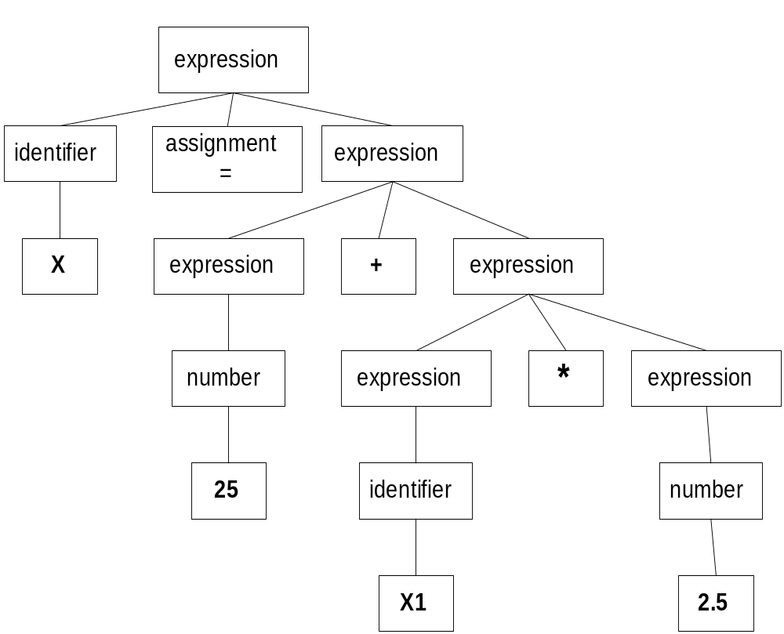

Semantic analysis

Semantic analysis phase checks if the source program contains semantic errors.

The main semantic action is type checking. Compiler checks that each operator has operands that permitted by the source language.

Example:
int x,z;
float y;
z=x/y;

z is integer, result of x/y is float
?

Semantic solution can be:
- error report
- changing a type of z
- casting of the result of x/y or casting of y.

Intermediate code generator

Intermediate code generator generates an intermediate representation of the source code, representation for an abstract target machine.

An intermediate language should be such a language that could be easily translated to the target program.

One of such languages is three–address code (TAC), a variation of assembly language with at most three operands.

Intermediate code representation of X = 25 + X1 * 2.5 is:

_tmp=X1*2.5
X=25+_tmp

Synthesis of the target program

Code optimization

Optimizer tries to improve code generated by the intermediate code generator. It takes intermediate code representation and attempts to create a smallest, fastest and most efficient code.

It attempts to get rid of unused variables, eliminates common sub-expressions, loop optimization.

Example:

Intermediate code:
t4=0
f0=t4
t5=1
t1=t4+t5
f1=t5
t6=2
i=t6
After optimization:
f0=0
f1=1
t1=0+1
i=2

Machine code generator

A final phase of the compiler is machine code generation.

Target program (or object code) is generated.

Usually target language is a machine code or an assembly code.

History of compilers

In late 50th a lot of computer machines and computer languages were build.

To create a compiler for L languages of M machines would require L*M programs.

why?
Each programming language should be translated into the target machine language.

In two-phase compilers front-end deals only with source language and back-end translates intermediate language into target machine language. So (ideally), if we agreed on unique intermediate language, only L+M programs would be needed.

3 major periods in the history of compiler are:
- 1945-1960
- 1960-1975
- 1975- present time.

≈1945-1960
–
New languages and machines were developed relatively slow
Most of the code was written directly in the language of machine commands.
Using a compiler was called “automatic programming”. It was 10-20 times slower than hand written assembly.

Very first compiler was written in assembly.

FORTRAN I compiler was developed in 1954-57. The project took 18 person-years. This compiler cut development time in half. (It had more “speaking-language-like” format). As a result by 1958 more than 50% of the software was written in FORTRAN.

≈1960-1975
–
A lot of new programming languages were developed.
For each language a new translator was required.
New “simple, quick and dirty” compilers were developed. They were not always efficient but it was better than no compiler at all.

Front-end techniques and tools were developed and more reliable compilers were built.

≈1975- present time
-
The number of different languages and machines decreased.
That reduced a need for so called “quick” compilers.

Compilers became reliable, efficient and fast. Optimization techniques for the back-end of the compiler are developed.

Compiler vs. interpreter

For some programming languages differences between interpreter and compiler are very fuzzy.

Interpreter is a program that takes program P written in some language and input x to P. It translates P and runs it on x and than gives a result - output of P on input x.
Interpreter is a translator plus virtual machine engine.
Runs program “as is” without any preprocessing or optimization.

Program P

interpreter
Output of P on x
Input x to P

Compiler takes source language and translates it into an equivalent target language program (string written in the target language).
Compiler is simply translator.

Target language program for P

compiler
Source program P
Properties of a good compiler

load module
Input to P
Output of P

assembler

1. It should generate a correct code.

2. No code or memory limitations should bother your compiler.
(By statistics programmer uses no more than 32 parameters and 128 declarations in his/her code. But usage of this statistics makes your compiler unreliable.)

3. Compilation speed is important.

4. “User-friendliness” – mainly in error reporting.
(Beginner programmers are often forget to put ‘;’ in the end of the line, but error messages they get do not help them to find an error.)

